|  |  |
| --- | --- |
| **C:\Users\CIET EEE\Desktop\logo.jpg** | **CHALAPATHI INSTITUTE OF ENGINEERING AND TECHNOLOGY**  **Chalapathi Nagar, Lam, Guntur-34** |

**DEPARTMENT OF ELECTRONICS AND COMMUNICATION ENGINEERING**

**Subject: – LINEAR CONTROL SYSTEMS**

|  |  |  |
| --- | --- | --- |
| Faculty Name: K.MURALI KRISHNA RAJU | Year / Sem: B.Tech in ECE 3/1 | Academic Year: 2019-20 |

**Result Analysis for Slow Learners from Assignment 1**

|  |  |
| --- | --- |
|  | **Assignment 1** |
| Students who have attended | 58 |
| Students who are qualified | 39 |
| Students not qualified | 19 |
| Students who are fast learners (>90%) | 15 |
| Students who are medium learners  (>50% & <90%) | 21 |
| Students who are slow learners (<50%) | 22 |

|  |  |
| --- | --- |
| **ROLL NUMBERS** | **REMEDIAL ACTION** |
| 1,31,34,35,36,37,38,39,40,43,44,45,47,48,50,51,52,53,54,55,56,57 | Weekly one question learning and writing process. spot evaluation |

**Questions given for very slow learners in A-I**

1. Define and explain open loop and closed loop system with an example?

2. Write the differential equations governing the mechanical rotational system show in fig and determine the transfer function

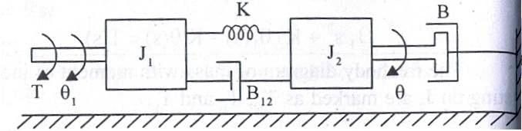

3. Find the transfer function for the sys tem represented by the block diagram show in fig

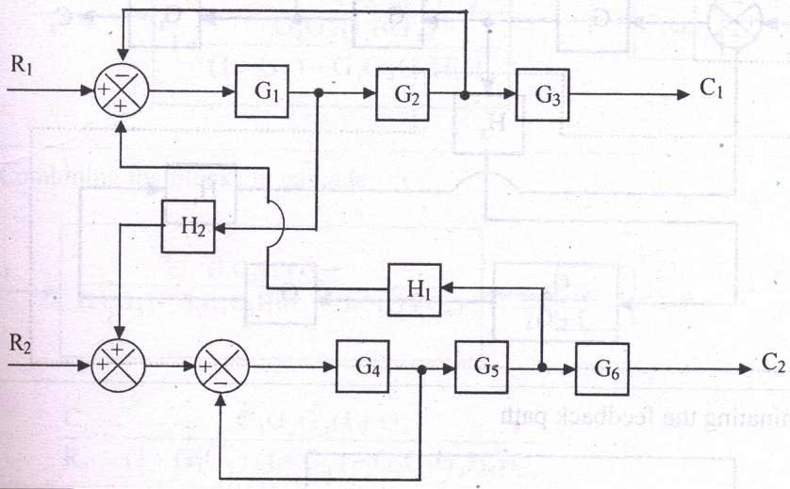

4. Find the overall gain of the system whose signal flow graph is show in fig

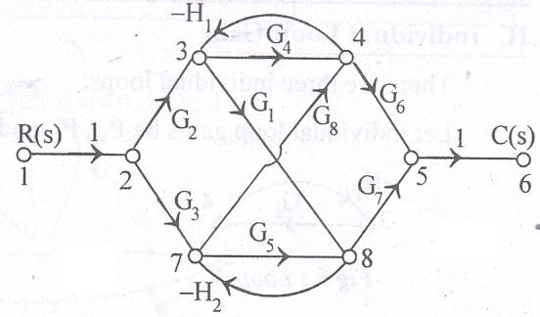

5. Explain the DC servo motor and derive its transfer function

6. Explain the synchro’s pair and derive its transfer function

**Signature of the faculty**

|  |  |
| --- | --- |
| **C:\Users\CIET EEE\Desktop\logo.jpg** | **CHALAPATHI INSTITUTE OF ENGINEERING AND TECHNOLOGY**  **Chalapathi Nagar, Lam, Guntur-34** |

**DEPARTMENT OF ELECTRONICS AND COMMUNICATION ENGINEERING**

**Subject: – LINEAR CONTROL SYSTEMS**

|  |  |  |
| --- | --- | --- |
| Faculty Name: K.MURALI KRISHNA RAJU | Year / Sem: B.Tech in ECE 3/1 | Academic Year: 2019-20 |

**List of students for Remedial from Assignment 1**

|  |  |  |  |  |
| --- | --- | --- | --- | --- |
| R.No | Reg.no | Name of student | Marks obtained | Student signature |
| 1 |  |  | 0 |  |
| 31 |  |  | 1 |  |
| 34 |  |  | 5 |  |
| 35 |  |  | 2 |  |
| 36 |  |  | 2 |  |
| 37 |  |  | 4 |  |
| 38 |  |  | 2 |  |
| 39 |  |  | 4 |  |
| 40 |  |  | 3 |  |
| 43 |  |  | 4 |  |
| 44 |  |  | 0 |  |
| 45 |  |  | 4 |  |
| 47 |  |  | 0 |  |
| 48 |  |  | 0 |  |
| 50 |  |  | 3 |  |
| 51 |  |  | 5 |  |
| 52 |  |  | 0 |  |
| 53 |  |  | 2 |  |
| 54 |  |  | 5 |  |
| 55 |  |  | 2 |  |
| 56 |  |  | 0 |  |
| 57 |  |  | 2 |  |

**Signature of the faculty**

|  |  |
| --- | --- |
| **C:\Users\CIET EEE\Desktop\logo.jpg** | **CHALAPATHI INSTITUTE OF ENGINEERING AND TECHNOLOGY**  **Chalapathi Nagar, Lam, Guntur-34** |

**DEPARTMENT OF ELECTRONICS AND COMMUNICATION ENGINEERING**

**Subject: – LINEAR CONTROL SYSTEMS**

|  |  |  |
| --- | --- | --- |
| Faculty Name: K.MURALI KRISHNA RAJU | Year / Sem: B.Tech in ECE 3/1 | Academic Year: 2019-20 |

**List of Advanced Learners from Assignment 1**

|  |  |  |  |  |  |
| --- | --- | --- | --- | --- | --- |
| S.NO | R. No | Reg. No | Name of the student | Activity | Delivery Date |
|  | 2 |  |  |  |  |
|  | 4 |  |  |  |  |
|  | 5 |  |  |  |  |
|  | 6 |  |  |  |  |
|  | 7 |  |  |  |  |
|  | 8 |  |  |  |  |
|  | 9 |  |  |  |  |
|  | 10 |  |  |  |  |
|  | 11 |  |  |  |  |
|  | 12 |  |  |  |  |
|  | 13 |  |  |  |  |
|  | 18 |  |  |  |  |
|  | 26 |  |  |  |  |
|  | 28 |  |  |  |  |
|  | 60 |  |  |  |  |

**Signature of the faculty**

|  |  |
| --- | --- |
| **C:\Users\CIET EEE\Desktop\logo.jpg** | **CHALAPATHI INSTITUTE OF ENGINEERING AND TECHNOLOGY**  **Chalapathi Nagar, Lam, Guntur-34** |

**DEPARTMENT OF ELECTRONICS AND COMMUNICATION ENGINEERING**

**Subject: – LINEAR CONTROL SYSTEMS**

|  |  |  |
| --- | --- | --- |
| Faculty Name: K.MURALI KRISHNA RAJU | Year / Sem: B.Tech in ECE 3/1 | Academic Year: 2019-20 |

**Result Analysis for Slow Learners from MID -I**

|  |  |
| --- | --- |
|  | MID -I |
| Students who have attended | 58 |
| Students who are qualified | 21 |
| Students not qualified | 37 |
| Students who are fast learners (>90%) | 04 |
| Students who are medium learners  (>50% & <90%) | 10 |
| Students who are slow learners (<50%) | 44 |

|  |  |
| --- | --- |
| **ROLL NUMBERS** | **REMEDIAL ACTION** |
|  | Weekly one question learning and writing process. spot evaluation |

**Questions given for very slow learners in M-I**

1. Explain the effect of feedback on overall gain and stability.

3. Find the transfer function of the control system shown in fig

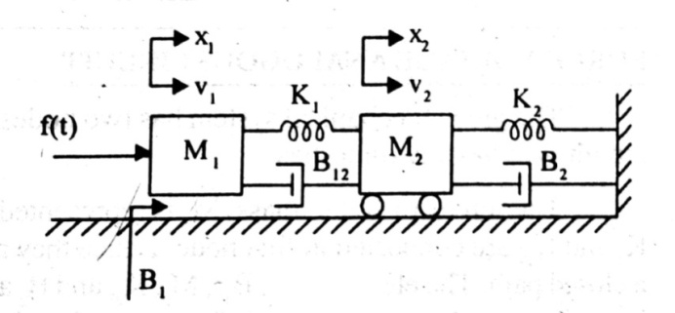

4. Define time response and explain time domain specifications 5. Find the stability of the system 

**Signature of the faculty**

|  |  |
| --- | --- |
| **C:\Users\CIET EEE\Desktop\logo.jpg** | **CHALAPATHI INSTITUTE OF ENGINEERING AND TECHNOLOGY**  **Chalapathi Nagar, Lam, Guntur-34** |

**DEPARTMENT OF ELECTRONICS AND COMMUNICATION ENGINEERING**

**Subject: – LINEAR CONTROL SYSTEMS**

|  |  |  |
| --- | --- | --- |
| Faculty Name: K.MURALI KRISHNA RAJU | Year / Sem: B.Tech in ECE 3/1 | Academic Year: 2019-20 |

**List of students for Remedial from MID –I**

|  |  |  |  |  |
| --- | --- | --- | --- | --- |
| R.No | Reg.no | Name of student | Marks obtained | Student signature |
| 1 |  |  | 0 |  |
| 3 |  |  | 6 |  |
| 6 |  |  | 6 |  |
| 8 |  |  | 8 |  |
| 13 |  |  | 4 |  |
| 15 |  |  | 4 |  |
| 16 |  |  | 3 |  |
| 17 |  |  | 2 |  |
| 20 |  |  | 3 |  |
| 21 |  |  | 5 |  |
| 22 |  |  | 4 |  |
| 23 |  |  | 1 |  |
| 24 |  |  | 5 |  |
| 25 |  |  | 7 |  |
| 26 |  |  | 8 |  |
| 27 |  |  | 8 |  |
| 29 |  |  | 0 |  |
| 31 |  |  | 0 |  |
| 32 |  |  | 2 |  |
| 33 |  |  | 6 |  |
| 34 |  |  | 6 |  |
| 35 |  |  | 4 |  |
| 36 |  |  | 0 |  |
| 37 |  |  | 0 |  |
| 38 |  |  | 1 |  |
| 39 |  |  | 6 |  |
| 40 |  |  | 5 |  |
| 42 |  |  | 0 |  |
| 43 |  |  | 1 |  |
| 44 |  |  | 1 |  |
| 45 |  |  | 8 |  |
| 46 |  |  | 0 |  |
| 47 |  |  | 0 |  |
| 48 |  |  | 0 |  |
| 49 |  |  | 3 |  |
| 50 |  |  | 4 |  |
| 51 |  |  | 7 |  |
| 52 |  |  | 0 |  |
| 53 |  |  | 1 |  |
| 54 |  |  | 4 |  |
| 55 |  |  | 0 |  |
| 56 |  |  | 0 |  |
| 57 |  |  | 2 |  |
| 58 |  |  | 2 |  |

**Questions given for very slow learners in M-I**

1. Explain the effect of feedback on overall gain and stability.

3. Find the transfer function of the control system shown in fig



4. Define time response and explain time domain specifications 5. Find the stability of the system 

**Signature of the faculty**

|  |  |
| --- | --- |
| **C:\Users\CIET EEE\Desktop\logo.jpg** | **CHALAPATHI INSTITUTE OF ENGINEERING AND TECHNOLOGY**  **Chalapathi Nagar, Lam, Guntur-34** |

**DEPARTMENT OF ELECTRONICS AND COMMUNICATION ENGINEERING**

**Subject: – LINEAR CONTROL SYSTEMS**

|  |  |  |
| --- | --- | --- |
| Faculty Name: K.MURALI KRISHNA RAJU | Year / Sem: B.Tech in ECE 3/1 | Academic Year: 2019-20 |

**List of Advanced Learners from MID -I**

|  |  |  |  |  |  |
| --- | --- | --- | --- | --- | --- |
| S.NO | R. No | Reg. No | Name of the student | Activity | Delivery Date |
|  |  | 4 |  |  |  |

**Signature of the faculty**

|  |  |
| --- | --- |
| **C:\Users\CIET EEE\Desktop\logo.jpg** | **CHALAPATHI INSTITUTE OF ENGINEERING AND TECHNOLOGY**  **Chalapathi Nagar, Lam, Guntur-34** |

**DEPARTMENT OF ELECTRONICS AND COMMUNICATION ENGINEERING**

**Subject: – LINEAR CONTROL SYSTEMS**

|  |  |  |
| --- | --- | --- |
| Faculty Name: K.MURALI KRISHNA RAJU | Year / Sem: B.Tech in ECE 3/1 | Academic Year: 2019-20 |

**Result Analysis at the end of the course**

|  |  |  |  |  |  |
| --- | --- | --- | --- | --- | --- |
|  | A1 | M1 | A2 | M2 | **Final** |
| Students who have attended | 58 | 58 |  |  |  |
| Students who are qualified | 39 | 21 |  |  |  |
| Students not qualified | 19 | 37 |  |  |  |
| Students who are fast learners(>90%) | 15 | 04 |  |  |  |
| Students who are medium learners  ( >50% & <90%) | 21 | 10 |  |  |  |
| Students who are slow learners (<50%) | 22 | 44 |  |  |  |

**Signature of the faculty**